DANCE CAPADES
REGISTRATION FORM

NAME: _____________________________________GRADE: ____BIRTHDATE. __________

ADDRESS: __________________________________________________________________

___________________________________________________________________

HOME PHONE: _______________________ CELL PHONE: _________________________

EMAIL ADDRESS: _____________________________________________________________

PARENT’S NAMES: __________________________ _______________________________
MOTHER FATHER
PREFERRED PERSON & METHOD TO CONTACT: _____________________________________
CAN WE SEND YOU TEXT MESSAGES PLEASE CIRCLE ONE: YES NO
EMERGENCY CONTACT (OTHER THAN PARENT): _____________________________________
PHONE: _____________________________________
ALLERGIES/MEDICAL CONDITIONS: _______________________________________________
____________________________________________________________________________
PREVIOUS DANCE EXPERIENCE: ____________________# OF YEARS: ____ ____ ____ ____ NAME OF DANCE STUDI0 Ballet Tap Jazz other
I give my child ________________________________________ permission to participate in classes at Dance Capades. I understand that the school and teachers are not liable for any injuries sustained during class, rehearsals, and/or performances, and I hereby release, waive, discharge and covenant not to sue Dance Capades, its owners and employees for any and all claims for personal injury, property damage, and/or any other damage arising out of my child’s participation in class, rehearsals, and/or performances and/or sustained by anyone observing the classes, rehearsals, and/or performances. I have read the accompanying flyer/information sheet, understand the information provided, and agree to abide by the rules and regulations. I _____ agree or do not agree ____ to allow my child’s photo to be used in advertisements and/or promotional information for the school.

_____________________________________ ____________________________________________
PRINT CHILD’S NAME PARENT’S SIGNATURE DATE

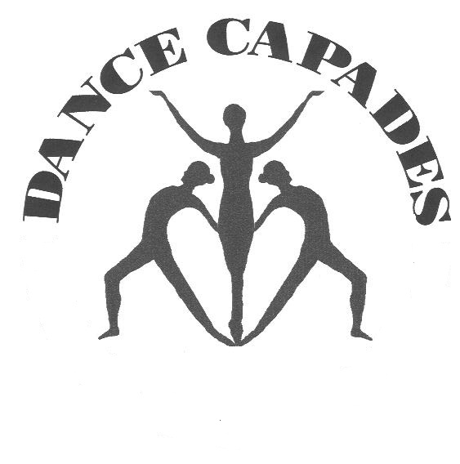

HEALTH RELEASE FORM

By signing this agreement, I acknowledge that Dance Capades has taken measures to keep all children and parents safe by following health guidelines that have been set forth for Dance Classes. I acknowledge the contagious nature of COVID-19 and voluntarily assume the risk that my child(ren) and I could be exposed to or infected with COVID-19 by attending Dance Capades in-person classes, and that such exposure could result in contracting the COVID-19 illness. I understand that exposure to COVID-19 may occur from the actions of myself and others, including, but not limited to, Dance Capades Owners, teachers, assistants, volunteers, students and their families, and South Presbyterian Church’s Minister and congregation. I voluntarily agree to assume all related risks and take sole responsibility for any illness or expense caused by COVID-19 to my child(ren) or myself, that may be experienced or incurred in connection with my or my child(ren)’s attendance at Dance Capades. On my behalf, and on behalf of my children and other household members, I hereby release, and hold harmless, Dance Capades LLC, its owners, teachers, agents and representatives from any Claims based on the actions of Dance Capades LLC, whether a COVID-19 infection occurs, before, during or after participation or presence at Dance Capades.

Student/Students Name(s)

_____________________________ _____________________________________ _____________
Parent/Guardian Name Parent/Guardian Signature Date

INSURANCE RELEASE FORM

I give my child ________________________________________ permission to participate in classes at Dance Capades. I understand that the school and teachers are not liable for any injuries sustained during class, rehearsals, and/or performances, and I hereby release, waive, discharge and covenant not to sue Dance Capades, its owners and employees for any and all claims for personal injury, property damage, and/or any other damage arising out of my child’s participation in class, rehearsals, and/or performances and/or sustained by anyone observing the classes, rehearsals, and/or performances. I have read the accompanying flyer/information sheet, understand the information provided, and agree to abide by the rules and regulations. I _____ agree or do not agree ____ to allow my child’s photo to be used in advertisements and/or promotional information for the school.

_____________________________ _________________________________________
PRINT CHILD’S NAME PARENT’S SIGNATURE

MASK PERMISSION SLIP

I give my child ___________________________________ permission to NOT wear a mask during dance class. I understand that the COVID 19 virus is still circulating and that masks add a layer of protection against the virus, however, I choose to allow my student to participate without a mask.

I would like my child ________________________________ to wear a mask during dance class.

_________________________________ _________________________________________
Parent’s Name (Print) Parent’s Signature

_______________
Date

